**Dylan Hutchinson - 11**

The absent student is in clear violation of the honor system. One of the core principles of the honor system is “maintaining honesty and fair play in all aspects of academic life at Stevens” (http://www.stevens.edu/honor/howitworks.shtml). That includes honestly reporting lecture attendance regardless of the grade impact. The fact that the misreporting only has a chance of affecting the absent student’s final grade (the professor may or may not bump up his grade based on attendance if it is on the border between grade levels) does not dismiss the fact that the absent student deliberately misreported his academic attendance to the professor. If one lies and later finds that no consequences ensued from lying, is the lie ethical? No! Likewise, the absent student’s lying about his class attendance is unethical and in violation.

The absent student’s accomplice (the one signing his name in) is also in violation of the honor board. While the accomplice must have had good attendance himself, he permitted and promoted the absent student’s dishonest behavior by signing his name. The accomplice needs to learn just as much as the absent student why misreporting attendance is an action unfair to the rest of the students who honestly report their attendance. Additionally, they both need to understand that their actions are unfair to themselves because they may lead to more serious unethical behavior in the future.

In deciding the penalties the two students receive, one must consider the gravity of their actions and the circumstances surrounding both students. Clearly misreporting attendance on its own is no serious crime; the maximum affect it could have on the absent student’s grade is one letter level and it may not affect the grade at all. But if no penalty were given, there would be no incentive for the students to contemplate their actions, learn from their errors, and in the best case, blossom into more ethical people in the future. The penalty matrix specifies the following:

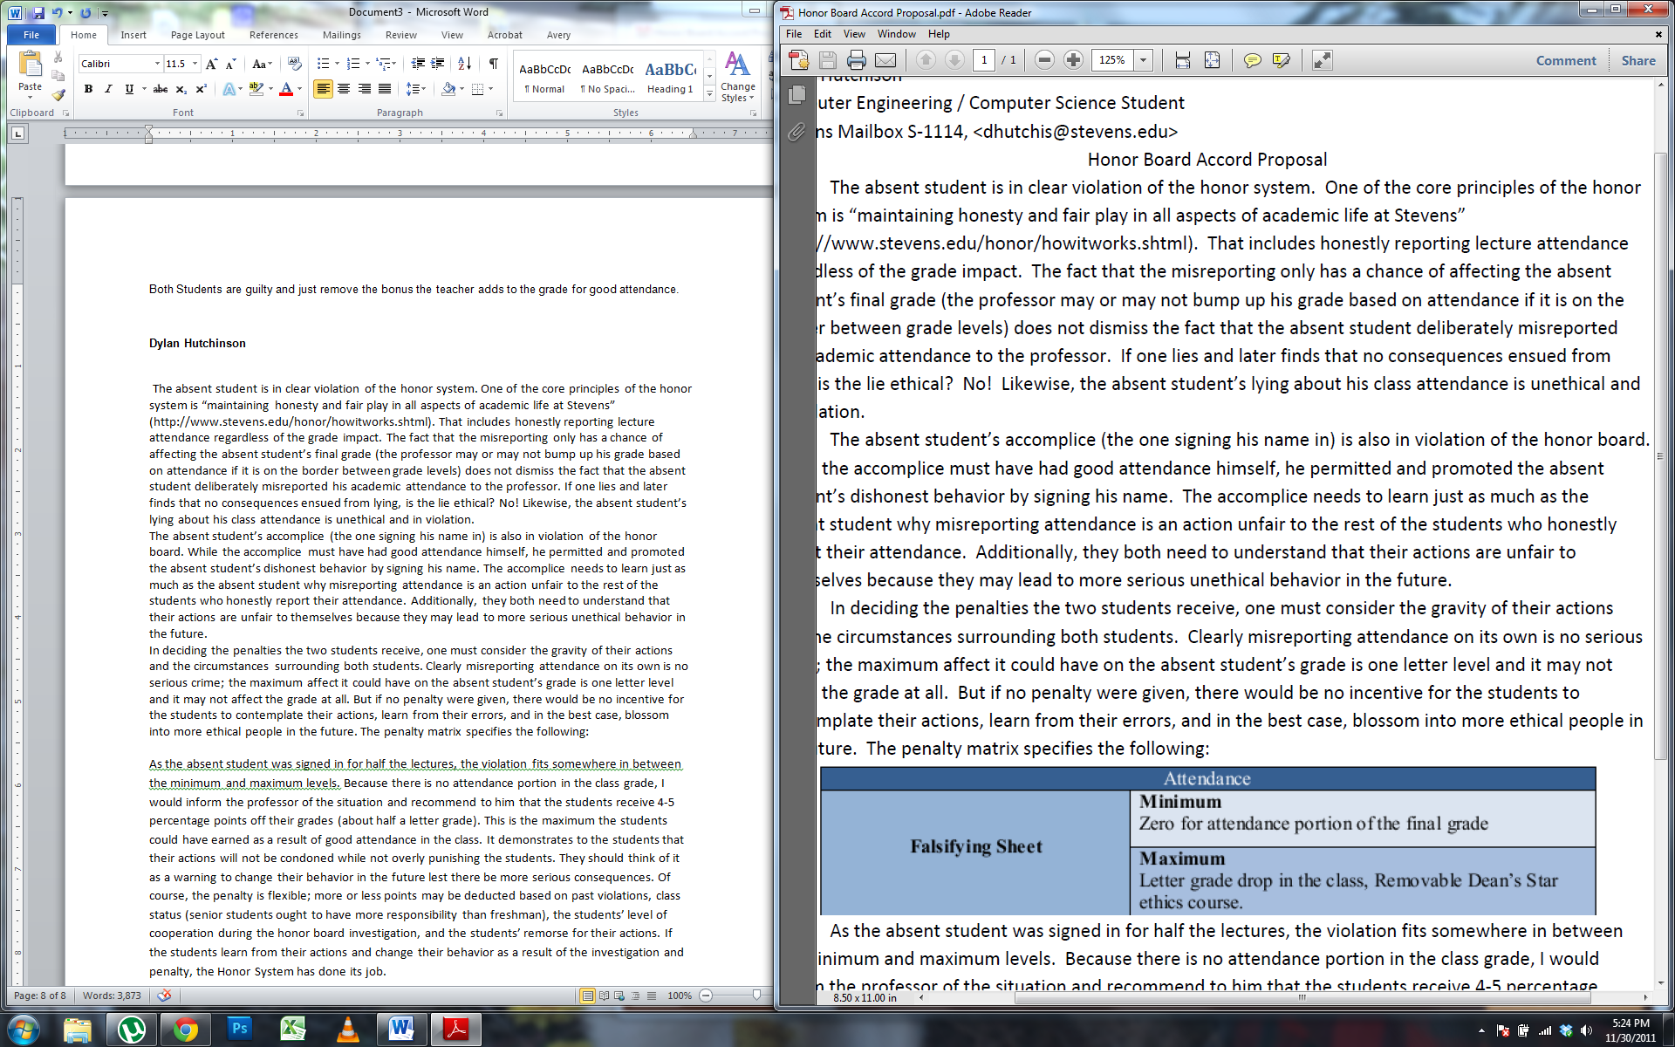

As the absent student was signed in for half the lectures, the violation fits somewhere in between the minimum and maximum levels. Because there is no attendance portion in the class grade, I would inform the professor of the situation and recommend to him that the students receive 4-5 percentage points off their grades (about half a letter grade). This is the maximum the students could have earned as a result of good attendance in the class. It demonstrates to the students that their actions will not be condoned while not overly punishing the students. They should think of it as a warning to change their behavior in the future lest there be more serious consequences. Of course, the penalty is flexible; more or less points may be deducted based on past violations, class status (senior students ought to have more responsibility than freshman), the students’ level of cooperation during the honor board investigation, and the students’ remorse for their actions. If the students learn from their actions and change their behavior as a result of the investigation and penalty, the Honor System has done its job.